“Data Cleaning, Analysis & Visualization with Excel”

- Data entry, import, and basic organization using tables

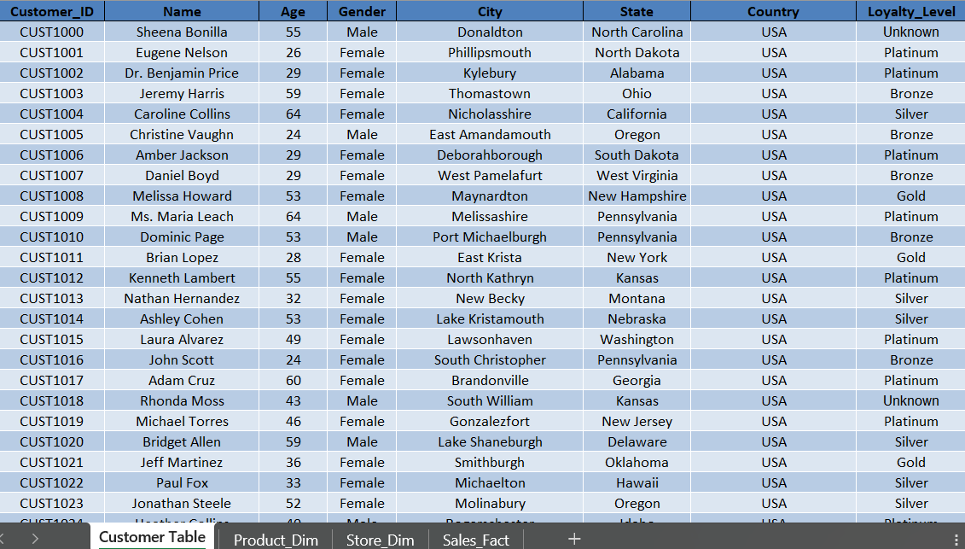

- Data cleaning: find/remove duplicates, handle missing/inconsistent data, correct formatting errors, and validate data

- Find and remove duplicates

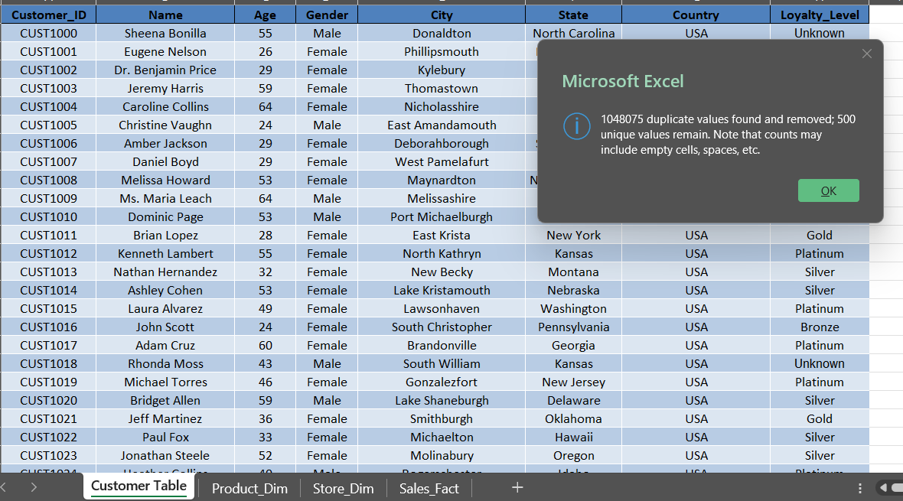
- Handle missing/inconsistent data, correct formatting errors, and validate data

Calculated_Amount in Sales_Fact

=F2*G2*(1-H2)

Calculate Quantity

=J2/(G2*(1-H2))

calculate Unit Price

=J2/(F2*(1-H2))

calculate Discount

=1-(J28/(F28*G28))

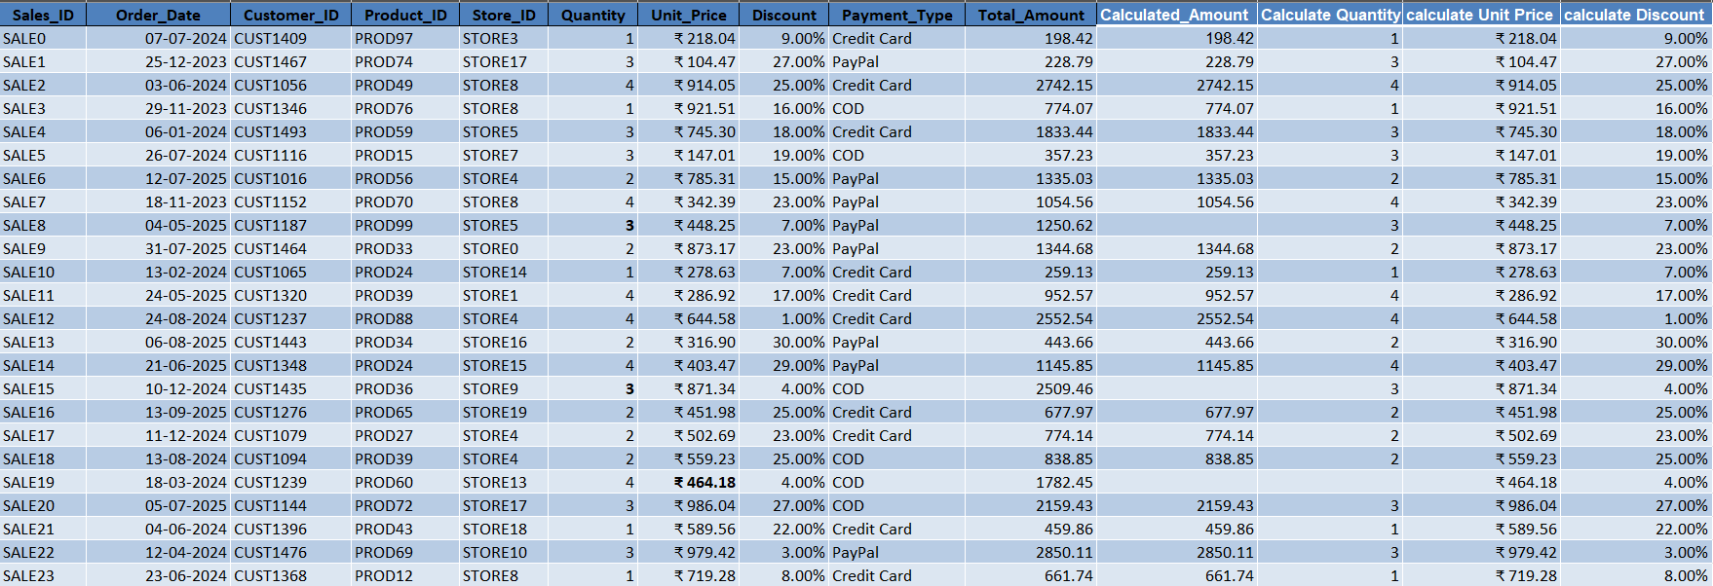

Calculate total sales

=SUM(J2:J2001)

Calculate average sales

=AVERAGE(J2:J2001)

Count transactions by payment type

=COUNTIF(I2:I2001,"PayPal")

Categorize sales as high or low value

=IF(J2>=1000,"High Value","Low Value")

Extract month and year from a date

=TEXT(B2,"mmm-yyyy")

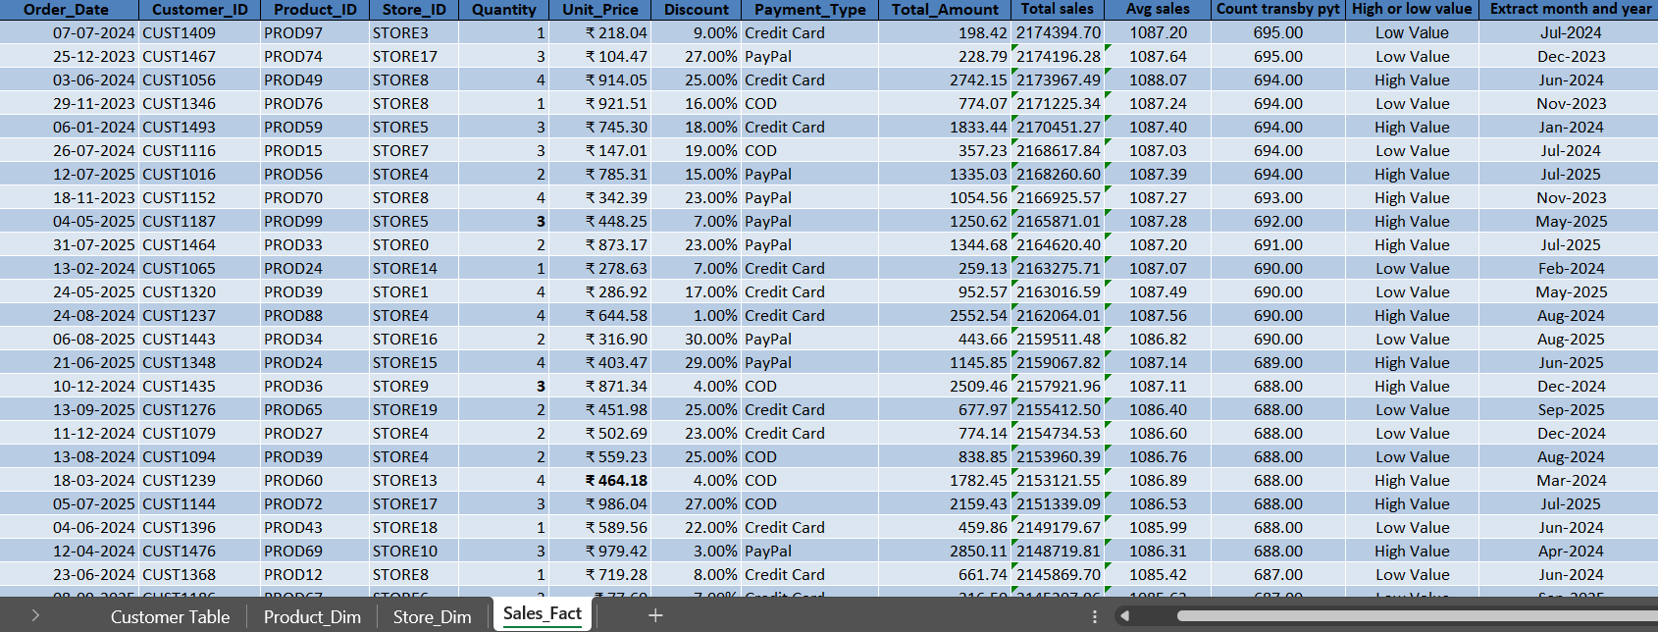

XLOOKUP for Sales_Fact and Product_Dim (Product_Name)

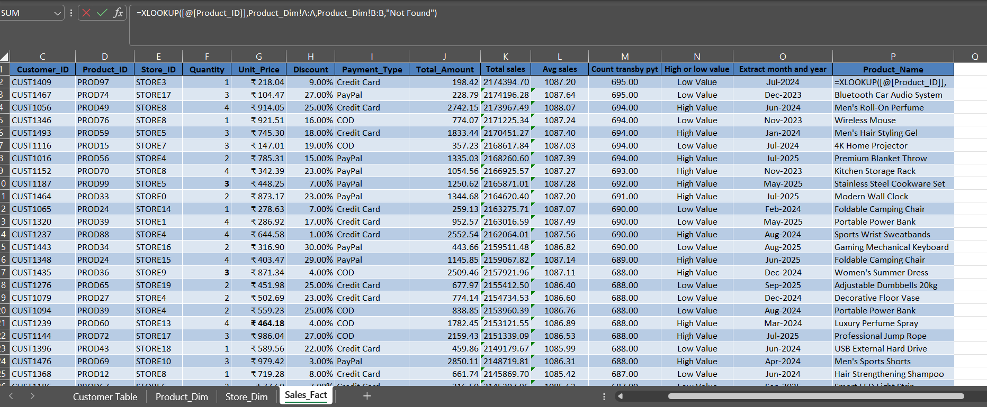

VLOOKUP for Sales_Fact and Product_Dim (Category)

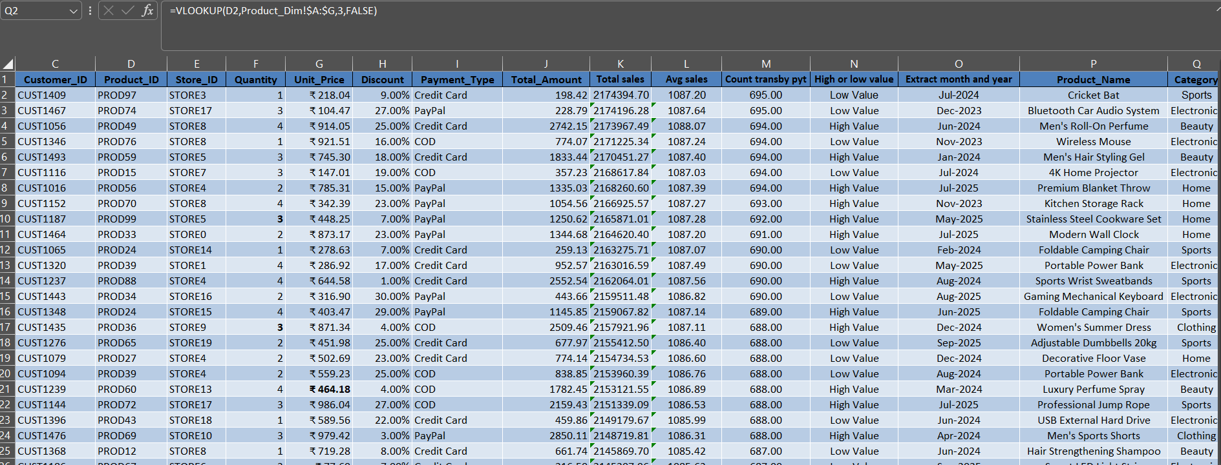

PIVOT

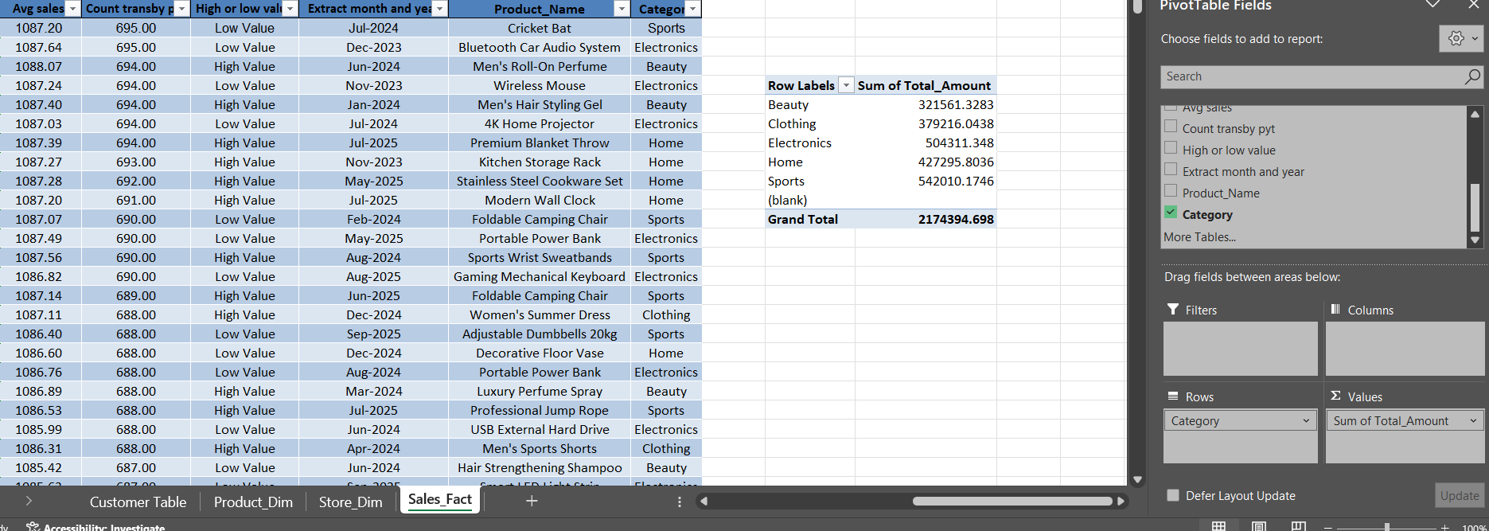

- Descriptive statistics (mean, median, mode, standard deviation, etc.) using formulas or Analysis ToolPak

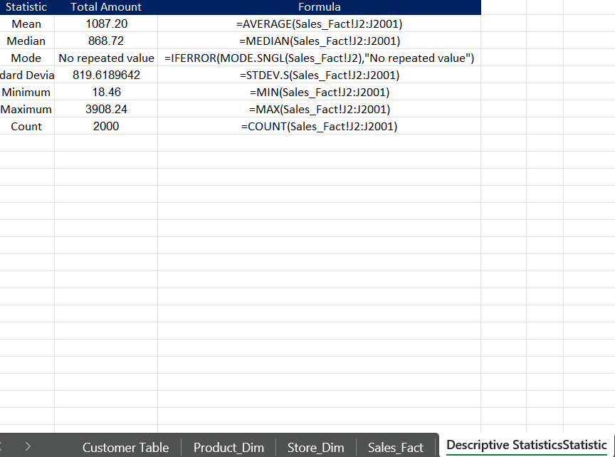

- Data visualization: create at least three chart types, build an interactive dashboard, and use basic PivotCharts

